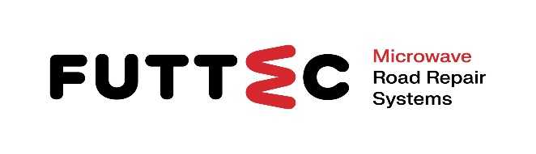 **PRESS RELEASE**

**12th February 2025**

**FUTTEC starts cooperation with DEK rental network**

**This will increase the availability of unique mobile microwave furnace sets (designed for year-round repair of potholes with hot packed asphalt mixture on lower-class roads) for municipalities**

**FUTTEC has concluded a cooperation agreement with a network of machine and equipment rental companies belonging to the Stavebniny DEK. Within the framework of the first phase, FUTTEC provided its machine set with FF-9 microwave furnace and a newly developed special asphalt mixture for loan to two key DEK branches (in Prague-Kbely and Žďár nad Sázavou): this mobile set is designed for year-round, fast and economically advantageous repairs of larger potholes on second and third-class roads with warm packed mixture. After greater demand comes, both partners plan to start offering the mobile sets in further DEK rental companies. The goal of this business strategy is to increase the use of FUTTEC's patented microwave technology for year-round non-invasive repair of defects on various types of asphalt roads and to increase the economic and regional availability of this innovative repair system for cities and municipalities.**

*"We are very happy that we are succeeding in expanding our microwave repair technology to lower-class roads in the cadastre of cities and municipalities. Thanks to the cooperation with the Stavebniny DEK, we can offer those interested another option to repair potholes on roads all year round, with high quality, quickly and economically. Until now, there were only two options: to order repairs directly from us, or to buy the FF-9 mobile machine set. Now, the customers can only calculate a sufficient amount of packed asphalt mixture (on average 3 to 4 bags per pothole) and then they can rent the FF-9 microwave furnace set in Stavebniny DEK branch,"* comments Jiří Rušikvas, [FUTTEC](http://www.futtec.cz).founder and owner.

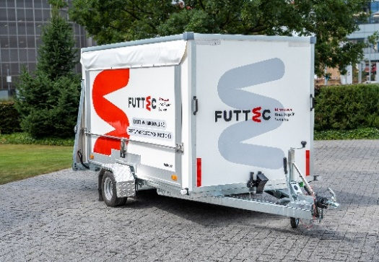

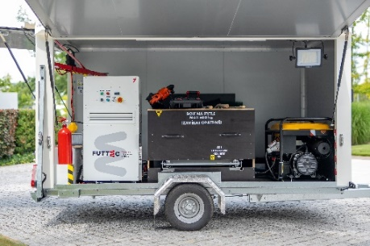The practical mobile set with a microwave furnace, which can now be borrowed by cities, municipalities, smaller construction companies and individuals at Stavebniny DEK branches, contains everything needed for fast, economical and, above all, year-round repair of potholes on lower-class roads: the FF-9 microwave furnace itself, an electric generator, a vibrating compaction plate and a container for 25kg bags with an innovative asphalt mixture developed by FUTTEC. This special mixture with controlled quality of the components used (including recycled material) optimizes the functionality of microwave heating, speeds up repairs and further improves their quality. Thanks to its steady, approximately eight-minute heating in a microwave furnace without degradation of the asphalt binder, the service life of repairs is extended and road maintenance costs are reduced.

*"Microwave technology, which allows interested parties to repair potholes with a high-quality and non-invasive warm packed mixture, is a truly unique solution that is missing on the Czech market. That is why we decided to include a mobile set with a microwave furnace in our portfolio,"* explains Rudolf Kreidl, product manager of [Stavebniny DEK](https://www.dek.cz/sekce/3-stavebniny), adding: *"It is also very easy to use: it can be operated by two people who do not need any extensive training. This machine quickly, gently and evenly heats the supplied asphalt mixture (even in the winter season down to a temperature of -5 °C), thus enabling high-quality repair of road defects."*

**Why FUTTEC microwave technology?**

The patented FUTTEC® technology is used for preventive non-invasive maintenance of asphalt roads. This system can seal potholes on the asphalt surface without creating a seam, changing the original parameters of the road (the repaired area is essentially returned to its original state) and requiring long-term closures, associated with detours and traffic jams. Year-round repairs are carried out using unique machines: a fleet of FT3 “microwave patchers” for complete seamless and waterproof repairs of potholes up to 80x80 cm in size. Separate sets with FF-9 microwave furnace are used to seal larger potholes using a special packed asphalt mixture: these are ideal for roads of second and third classes in the cadastre of cities and municipalities.

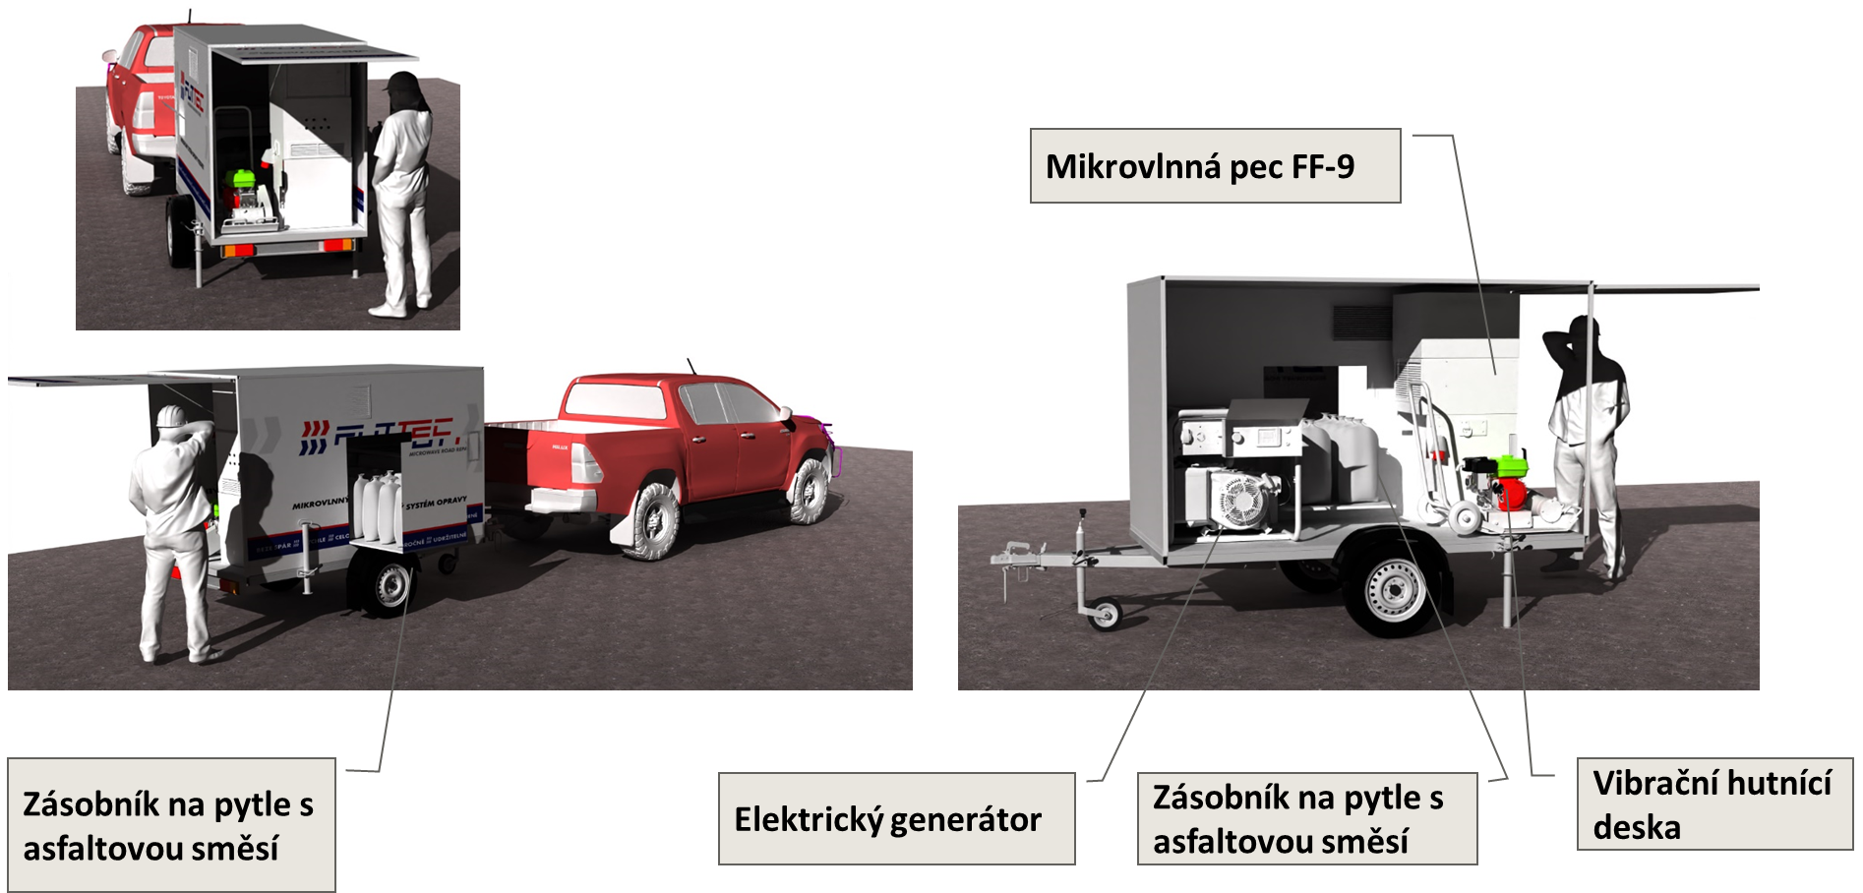

**More about DEK Holding:**

*Stavebniny DEK a. s. is a part of DEK a. s. holding which is engaged in the supply and production of materials for the construction industry and services for the construction market. Stavebniny DEK is the largest supplier in the Czech Republic and the leading supplier of materials for roofs, facades and insulation in the Slovak Republic. Currently, holding DEK a. s. operates more than 140 sales warehouses and employs over 4,600 employees.*

**More about FUTTEC and its patented microwave technology:**

*FUTTEC has developed from a small Czech start-up, founded in 2011, into a dynamic technology company. Its microwave technology, which is the result of many years of research and improvement, was created in cooperation with the Institute of Chemical Processes of the Academy of Sciences of the Czech Republic and BUT in Brno. The company is currently developing the 4th generation of its machines ("microwave patchers" of the FT3 series and mobile sets with a microwave furnace FF-9), cooperating with all types of domestic road administrators (including TSK Prague, ŘSD and regional SÚS) and expanding into foreign markets - e.g. the USA.*

*The patented FUTTEC® technology is designed for permanent repairs of potholes in asphalt surfaces on roads, cycle paths and other asphalt surfaces. It works on the principle of heating asphalt mixtures using microwave technology, which ensures deep heating of the repaired area without degrading the asphalt mixture. The result is high strength and long service life of the repaired area. Thanks to this principle, road repairs can be carried out all year round, including in winter. Other advantages of FUTTEC microwave technology include speed, flexibility, efficiency and savings in costs and human resources, environmental friendliness, health safety and transparency (during the repair, a protocol is created, which is a warranty certificate for the repair).*

***More information:***

**Crest Communications**

Marie Cimplová, phone 731 613 602, [marie.cimplova@crestcom.cz](mailto:marie.cimplova@crestcom.cz)

Kamila Čadková, phone: 731 613 609, [kamila.cadkova@crestcom.cz](mailto:kamila.cadkova@crestcom.cz)

[**www.crestcom.cz**](http://www.crestcom.cz)

**FUTTEC**

Ondřej Rušikvas, phone 602 363 204, [ondrej.rusikvas@futtec.cz](mailto:ondrej.rusikvas@futtec.cz)

[**www.futtec.cz**](http://www.futtec.cz)