** PRESS RELEASE**

**29th April 2025**

**Don't wait for spring, repair roads anytime. There is only one permanent solution: microwaves!**

**Repair using microwave technology can be carried out within tens of minutes. It is cost-effective, high-quality and long-lasting. It can be used not only for repairing potholes that have already formed, but also as a maintenance technology that can prevent extensive damage to the road surface, endangering road traffic and long-term closures.**

Every spring, road workers go to Czech roads to begin a regular cycle of asphalt surface repairs. On class II and III roads, drivers then witness repeated closures, associated detours and traffic jams. What is the cause? Temporary winter repairs of potholes with cold packed mixture, which is simply poured into the pothole and compacted, are often to blame. A gap is created between this mixture and the existing material, into which water flows: the effect of frost causes the expansion of the crack due to which the pothole soon appears again. Road workers must therefore return to the repaired areas repeatedly, which is uneconomical in terms of finances as well as material and human resources. Similar problems are also brought by the use of other, lower-quality methods associated with milling (when the damaged area becomes even larger) or burning the asphalt binder. A year-round, economically affordable solution is to use the FF-9 microwave furnace set, developed by the Czech company FUTTEC. It is designed for quick and non-invasive repairs of larger potholes on asphalt surfaces using a gently and evenly heated packaged mixture.

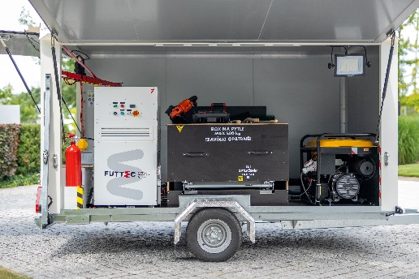[The FF-9 microwave furnace set](https://futtec.cz/en/machine/ff-9-microwave-furnace-set/) will be used not only by cities and municipalities that have damaged lower-class roads, parking lots and cycle paths in their cadastre, but also by companies in their logistics and warehouse areas or individuals who want to repair their driveway. The mobile trailer set with a microwave furnace can be purchased or rented from the DEK rental network (or repairs can be ordered also directly from FUTTEC). It is also very easy to operate, and therefore its user does not need any special training. A 25kg bag of new asphalt mixture, which is part of the mobile set (together with the electric generator and the compaction plate), is placed in the furnace: this material is gently and evenly heated in it within approximately 10 minutes, so that the asphalt binder does not burn. It is then poured into the cleaned pothole, spread with a rake and compacted. Thanks to the preparation of the required amount of mixture directly on site, no waste is generated that would need to be transported and disposed of.

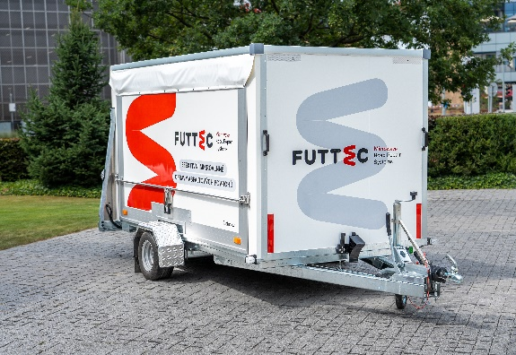

*"We are changing the procedures that have been used for years to repair class II and III roads. Although these roads are often exposed to excessive traffic load, it happens that there are no funds left in the budget for their high-quality repair: their surface, which is often nearing the end of its service life, is then full of cracks and potholes from which the cold packed mixture has crumbled – and more are added. Repairs with hot packed mixture using the FF-9 microwave furnace are flexible, fast, environmentally friendly and economically affordable. It is a solution for all cities and municipalities that want to act with the care of a proper manager. So that it is not necessary to repair one pothole provisionally over and over again with cold packed mixture, which is the most common practice in the Czech Republic. The microwave furnace can repair one pothole of up to 2 m2 in just tens of minutes. And it can be used at outdoor temperatures from -10 to 40 °C. Moreover, fast and preventive pothole repair using microwaves reduces the total cost of road maintenance by up to half," comments Jiří Rušikvas, owner and founder of FUTTEC, and adds: "We are currently organizing a roadshow around the regions of the Czech Republic, during which we present to representatives of cities and municipalities the principle on which our technology works. This way, they can personally see how the repair itself is carried out in practice."*

**QUICK AND QUALITY REPAIR OF POTHOLES WITH A MICROWAVE FURNACE IN 5 STEPS**

|  |  |
| --- | --- |
| *Preparation :1-2 minutes* | The mobile trailer set with microwave furnace arrives at the repair site. This is indicated by traffic signs. |
| *3.-13. minute* | A 25kg bag of new asphalt mixture is placed in the furnace, where it is gently and evenly heated to approx. 160°C. In the meantime, it is time to clean the pothole. |
| *13.- 16. minute* | The heated asphalt mixture (its temperature can be checked with a special thermometer) is poured into the pothole and spread with a rake. |
| *16.-20. minute* | The repaired area is compacted with a compaction plate. |
| *21-30. minute\** | The quality repair is completely finished and the mobile trailer set is leaving. It is possible to drive on the repaired pothole after it has cooled down slightly. (The repaired area has a temperature below 40 °C.) |

*\*This figure depends on the size of the pothole and the number of bags heated (one large pothole = 75 kg of mixture = 3 bags = 30 minutes)*

***A demonstration of repair using FF-9 microwave furnace set:***

[Video FF-9_Microwave Furnace Set - FUTTEC](https://www.youtube.com/watch?v=u8I1mPGI8tA)

**More about FUTTEC and its patented microwave technology:**

*FUTTEC has developed from a small Czech start-up, founded in 2011, into a dynamic technology company. Its microwave technology, which is the result of many years of research and improvement, was created in cooperation with the Institute of Chemical Processes of the Academy of Sciences of the Czech Republic and BUT in Brno. The company is currently developing the 4th generation of its machines ("microwave patchers" of the FT3 series and mobile sets with a microwave furnace FF-9), cooperating with all types of domestic road administrators (including TSK Prague, ŘSD and regional SÚS) and expanding into foreign markets - e.g. the USA.*

*The patented FUTTEC® technology is designed for permanent repairs of potholes in asphalt surfaces on roads, cycle paths and other asphalt surfaces. It works on the principle of heating asphalt mixtures using microwave technology, which ensures deep heating of the repaired area without degrading the asphalt mixture. The result is high strength and long service life of the repaired area. Thanks to this principle, road repairs can be carried out all year round, including in winter. Other advantages of FUTTEC microwave technology include speed, flexibility, efficiency and savings in costs and human resources, environmental friendliness, health safety and transparency (during the repair, a protocol is created, which is a warranty certificate for the repair).*

***More information:***

**Crest Communications**

Marie Cimplová, phone 731 613 602, [marie.cimplova@crestcom.cz](mailto:marie.cimplova@crestcom.cz)

Kamila Čadková, phone: 731 613 609, [kamila.cadkova@crestcom.cz](mailto:kamila.cadkova@crestcom.cz)

[**www.crestcom.cz**](http://www.crestcom.cz)

**FUTTEC**

Ondřej Rušikvas, phone 602 363 204, [ondrej.rusikvas@futtec.cz](mailto:ondrej.rusikvas@futtec.cz)

[**www.futtec.cz**](http://www.futtec.cz)