** PRESS RELEASE**

**27th May 2025**

**Breakthrough year 2024 for FUTTEC**

* **With its revolutionary microwave technology FUTTEC®, the company repaired over 7,700 potholes on Czech roads of all types**
* **FUTTEC expanded abroad and founded a new company in the USA**
* **The company produced the third generation of microwave machines for year-round seamless pothole repairs and began development of the fourth**
* **FUTTEC achieved the highest turnover in its history**

**The Czech company FUTTEC closed last successful year with the highest turnover in its history: an eightfold increase compared to 2023. Thanks to a significant strengthening of cooperation with Czech road administrators (TSK Prague, ŘSD and regional SÚS), it repaired over 7,700 potholes on motorways and asphalt roads of all classes. At the same time, it accelerated its business expansion abroad, especially to the USA: in cooperation with renowned American businessman Michael Seifert, it founded a new company there, which will soon launch the innovative FUTTEC microwave system on North American and Canadian roads. In addition, the FUTTEC development team expanded the company's fleet of machines for high-quality, year-round and non-invasive pothole repairs on asphalt roads with the third generation of the FT-3 series "microwave patcher" and separate sets with a FF-9 microwave furnace.**

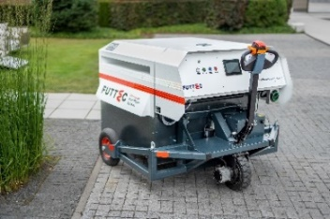[FUTTEC](http://www.futtec.cz) began its rapid expansion on Czech roads 4 years ago, when it produced a prototype – the first generation of the FT-3 series “microwave patcher” and began trial repairs of potholes on asphalt surfaces with it. Throughout 2024, it has already successfully repaired approx. 7,700 potholes on all types of roads, 40 % of which were repaired in winter and 90 % at night to prevent traffic restrictions and to maintain road safety. The almost 300% increase in the number of repairs compared to 2023 is the result of deepening cooperation with the majority of domestic road administrators who manage motorways and class I roads. The company also presented an effective solution for private companies and especially municipalities that have severely damaged class II and III roads in their cadastre: they can buy or rent a separate mobile set with a microwave furnace FF-9 from the DEK network of machine and equipment rental company. In addition, using Big Data and artificial intelligence, FUTTEC is working intensively on the development of a comprehensive repair ecosystem based on smart monitoring of potholes and cracks, early detection of places at risk, and preventive seamless maintenance of asphalt roads.

*FT-3 series “microwave patcher“*

*"Last year was truly a turning point for us. I consider the greatest success to be that we managed to prove in practice that the microwave method of repairing potholes and cracks is the only one on the market that is truly high-quality, fast and friendly to the asphalt mixture and the environment. And as a result, it is also economically effective. It can restore the parameters of the original road to the repaired area, which also significantly contributes to smoother traffic flow and its safety,"* says Jiří Rušikvas, founder and owner of FUTTEC, and continues*: "In 2025, we want to focus primarily on three areas, not counting the development of our company in the area of ​​human resources. The first is development, research and intensive field work, which will help us gain further experience, fine-tune technological details and prepare 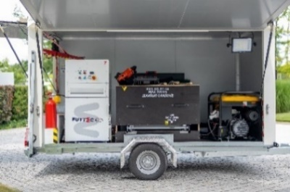our machines for mass production. We also plan to further strengthen our cooperation with all types of road administrators - including municipalities, to which we would like to provide a comprehensive microwave maintenance ecosystem including our complete support. And we also consider continuing our expansion abroad to be very important."*

*Mobile set with microwave furnace FF-9*

Ondřej Rušikvas, commercial director of FUTTEC, comments on the foreign expansion, which the company significantly accelerated last year: *"Last year, we participated in many trade missions and meetings abroad, during which we presented our microwave system and established a number of business contacts: whether it was European countries such as Germany, Austria and Montenegro, or the United Arab Emirates. The symbolic culmination of last year's success in the field of foreign expansion was the establishment of the new company FUTTEC North America, which will soon begin the first test repairs using the FT3 series "microwave patchers" on local roads. Part of our longer-term plans is the analysis of other business opportunities in foreign markets and ensuring that microwave technology repairs become synonymous with preventive maintenance of asphalt surfaces anywhere in the world.”*

*Last year, FUTTEC obtained the international standard ISO 9001, which sets requirements for a quality management system and provides certification that the company is able to deliver a product or service that meets expectations and complies with legal requirements.*

**More about FUTTEC and its patented microwave technology:**

*FUTTEC has developed from a small Czech start-up, founded in 2011, into a dynamic technology company. Its microwave technology, which is the result of many years of research and improvement, was created in cooperation with the Institute of Chemical Processes of the Academy of Sciences of the Czech Republic and BUT in Brno. The company is currently developing the 4th generation of its machines ("microwave patchers" of the FT3 series and mobile sets with a microwave furnace FF-9), cooperating with all types of domestic road administrators (including TSK Prague, ŘSD and regional SÚS) and expanding into foreign markets - e.g. the USA.*

*The patented FUTTEC® technology is designed for permanent repairs of potholes in asphalt surfaces on roads, cycle paths and other asphalt surfaces. It works on the principle of heating asphalt mixtures using microwave technology, which ensures deep heating of the repaired area without degrading the asphalt mixture. The result is high strength and long service life of the repaired area. Thanks to this principle, road repairs can be carried out all year round, including in winter. Other advantages of FUTTEC microwave technology include speed, flexibility, efficiency and savings in costs and human resources, environmental friendliness, health safety and transparency (during the repair, a protocol is created, which is a warranty certificate for the repair).*

***More information:***

**Crest Communications**

Marie Cimplová, phone 731 613 602, [marie.cimplova@crestcom.cz](mailto:marie.cimplova@crestcom.cz)

Kamila Čadková, phone: 731 613 609, [kamila.cadkova@crestcom.cz](mailto:kamila.cadkova@crestcom.cz)

[**www.crestcom.cz**](http://www.crestcom.cz)

**FUTTEC**

Ondřej Rušikvas, phone 602 363 204, [ondrej.rusikvas@futtec.cz](mailto:ondrej.rusikvas@futtec.cz)

[**www.futtec.cz**](http://www.futtec.cz)