
PRESS RELEASE

27th November 2025
____________________________________________________________

Cold weather is coming – and with it, a warm packaged asphalt mixture to the roads

How to repair potholes on roads in a high-quality and durable way even in winter?
Using a special warm packaged asphalt mixture and FUTTEC microwave technology

In winter, potholes and cracks often appear on roads, which road workers usually only temporarily fill with a mixture of aggregates coated with cold asphalt emulsion (packaging plants with warm asphalt mixture are closed in winter). However, these emergency interventions only have a short-term effect – with water flowing into the joints and with its continuous thawing and freezing, the potholes soon reappear, enlarge, and the overall condition of the road deteriorates. However, a permanent, high-quality and effective solution exists even in winter: the patented FUTTEC™ microwave technology. It uses a special warm packaged asphalt mixture, gently and evenly heated in a microwave furnace. This furnace is either part of the accessories for the FT-3 "microwave patcher" or a separate mobile set suitable for repairs of lower-class roads. Thanks to FUTTEC's own logistics centre, road managers have year-round access to this mixture in the required volume, bagged in 25 kilograms. This means they can use the warm packaging even in the winter season, and in addition, they do not generate unnecessary waste or costs for unused material.
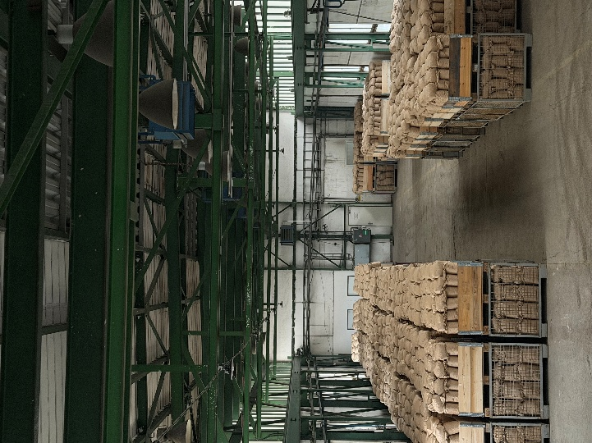
FUTTEC has recently innovated its business model. Previously, its microwave equipment could only be rented or repairs ordered directly from it (as in the case of FUTTEC's cooperation with the road administrators TSK Prague, ŘSD or SÚS). Now, it is possible to purchase a mobile set with an FF-9 microwave furnace from FUTTEC, as the licensee, who continues to provide a complete service. Or, it is possible to purchase just a separate furnace, which the user can place in a van, for example - in this way, he can have his own "mobile packaging plant" at a disposal, which provides him with warm packaged mixture all year round.

"It is common for maintenance work to be postponed until spring, or potholes to be temporarily patched with cold packed asphalt. However, the use of poor-quality material or technology only leads to roads often being in worse condition after winter than before. The solution is continuous care for roads with FUTTEC microwave machines - whether it is a more sophisticated FT-3 "microwave patcher" supplemented with microwave furnaces, used to heat the mixture and the repaired area, or a separate microwave furnace that gently heats only the bagged asphalt mixture. Thanks to the principle on which these devices work, they are not dependent on supplies of warm asphalt mixture from asphalt plants, which have a seasonal shutdown in winter, or on less durable cold packed asphalt. They can be used to repair not only roads, but also parking lots, cycle paths or special-purpose roads, the maintenance of which would otherwise be postponed until the warmer season," explains Jiří Rušikvas, founder of FUTTEC.

Operating the microwave furnace and preparing the warm packaged mixture is very easy. First, the user orders the required number of 25kg bags of special asphalt mixture from the FUTTEC distribution centre, which has a controlled quality of all components, including recycled material. They are then gradually placed directly into the furnace: the material from one 25kg bag is gently and evenly heated in it within approximately 10 minutes, so that the asphalt binder is not burned. The heated mixture is then poured into the cleaned (in the case of working with the FT-3 “microwave patcher” also preheated) pothole, spread with a rake and thoroughly compacted. Thanks to heating the required amount of mixture directly on site, no waste is generated that would need to be transported and disposed of.

More about FUTTEC and its patented microwave technology:
FUTTEC has developed from a small Czech start-up, founded in 2011, into a dynamic technology company. Its microwave technology, which is the result of many years of research and improvement, was created in cooperation with the Institute of Chemical Processes of the Academy of Sciences of the Czech Republic and BUT in Brno. The company is currently developing the 4th generation of its machines ("microwave patchers" of the FT3 series and mobile sets with a microwave furnace FF-9), cooperating with all types of domestic road administrators (including TSK Prague, ŘSD and regional SÚS) and expanding into foreign markets - e.g. the USA.

The patented FUTTEC® technology is designed for permanent repairs of potholes in asphalt surfaces on roads, cycle paths and other asphalt surfaces. It works on the principle of heating asphalt mixtures using microwave technology, which ensures deep heating of the repaired area without degrading the asphalt mixture. The result is high strength and long service life of the repaired area. Thanks to this principle, road repairs can be carried out all year round, including in winter. Other advantages of FUTTEC microwave technology include speed, flexibility, efficiency and savings in costs and human resources, environmental friendliness, health safety and transparency (during the repair, a protocol is created, which is a warranty certificate for the repair).

