
PRESS RELEASE

9th June 2026
____________________________________________________________

Will European roads be better? FUTTEC enters Europe

Company presents its patented microwave pothole repair technology directly on site

The Czech company FUTTEC continues to expand its presence in European markets through live demonstrations of its microwave technology for repairing potholes on asphalt roads. Since February 2026, it has presented it to experts, road managers, and representatives of construction companies in the Netherlands, Italy, Romania, and Hungary. In the coming months, it will also head to Austria, Switzerland, Ireland, and Norway. Practical demonstrations of pothole repairs directly in real operation are the best way to demonstrate the main benefits of the microwave solution – quality, durability, increased work safety, minimal traffic restrictions, and a more environmentally friendly approach. Live presentations allow transport infrastructure managers and business partners to see the entire process in practice, assess its operational simplicity, speed and efficiency and see the quality result on site.

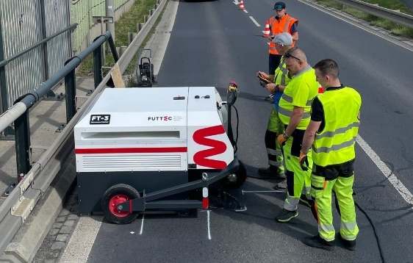
“Live demonstrations are essential when entering new markets. No presentation at a trade fair or at a conference, nor a technical brochure, can replace the moment when interested parties see a repair directly on the road and can observe the entire process with their own eyes. This is when trust and a real understanding of what our technology can do are built the fastest,” says Robert Husár, International Business Director at FUTTEC. “Sometimes participants come a little skeptical, however, they rapidly change their view during a single demonstration. Once they see the technology in practice, the discussion very quickly shifts from the question ‘is this real?’ to the question of ‘how do we get it on our roads?’ And that is what we are now intensively addressing,” he adds.
Repair using the “microwave patcher“ FT-3

Demo tour across Europe
The first foreign presentation of the patented FUTTEC microwave technology this year took place in February 2026 in the Dutch city of Zwolle in cooperation with Intertechno, a potential FUTTEC partner for the local market. This was followed in the spring by demonstrations in Bucharest (Romania), and Bologna (Italy) where FUTTEC will also be present at the important international trade fair Asphaltica in October this year. In the coming months, it plans to head to Budapest (Hungary), Raibach im Mühlkreis (Austria), Bern (Switzerland), Limerick (Ireland), and Trondheim (Norway).

"Potholes repairs using FUTTEC microwave technology are becoming a standard on Czech roads – currently, we are already cooperating intensively with all types of domestic road administrators, including the ŘSD (Directorate of Roads and Highways), regional SÚS (Road Management and Maintenance) or TSK Prague (Technical Management of Roads). Part of our long-term strategy is naturally also the active search for business opportunities in foreign markets with the aim of making repairs using microwave technology a common part of preventive maintenance of asphalt surfaces around the world. The ever-expanding series of international presentations confirms the growing interest of European cities, regions and private companies in more modern and effective methods of road repairs," concludes Ondřej Rušikvas, Chief Commercial Officer at FUTTEC.

Why FUTTEC microwave technology?
The patented FUTTEC® technology is used for preventive and very gentle maintenance of asphalt pavements. This system can seal a pothole on the asphalt surface without creating a joint, changing the original parameters of the road (the repaired area is essentially returned to its original state) and requiring long-term closures associated with detours and traffic jams. FUTTEC customers perform year-round permanent repairs using sets equipped with the FT-3 “microwave patcher” and integrated mobile FF-9 microwave furnaces. For temporary repairs of defects, sets or trucks equipped only with FF-9 microwave furnaces for heating the bagged asphalt mixture are used.

More about FUTTEC and its patented microwave technology:
FUTTEC has developed from a small Czech start-up, founded in 2011, into a dynamic technology company. Its microwave technology, which is the result of many years of research and improvement, was created in cooperation with the Institute of Chemical Processes of the Academy of Sciences of the Czech Republic and BUT in Brno. The company has been working on the development of its "microwave patchers" of the FT-3 series and mobile sets with the FF-9 microwave furnace, cooperating with all types of domestic road administrators (including TSK Prague, ŘSD and regional SÚS) and expanding into foreign markets - e.g. the USA.

The patented FUTTEC® technology is designed for permanent repairs of potholes in asphalt surfaces on roads, cycle paths, and other asphalt surfaces. It works on the principle of heating asphalt mixtures using microwave technology, which ensures deep heating of the repaired area without degrading the asphalt mixture. The result is high strength and long service life of the repaired area. Thanks to this principle, road repairs can be carried out all year round, including in winter. Other advantages of FUTTEC microwave technology include speed, flexibility, efficiency, and savings in costs and human resources, environmental friendliness, health safety and transparency (during the repair, a protocol is created, which is a warranty certificate for the repair).

