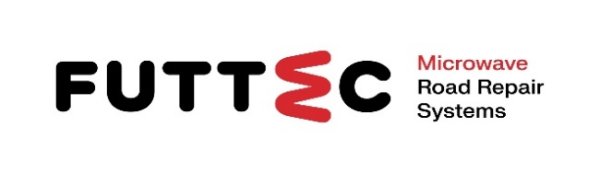 **PRESS RELEASE**

**11th December 2024**

**FUTTEC expands its business to North America:**

**it establishes a new company in the USA**

**and starts potholes repair with microwave technology here**

**The Czech company FUTTEC, which developed a unique microwave system for year-round, durable and non-invasive repair of potholes on asphalt roads, is expanding to the USA. As part of a strategic agreement with renowned American businessman Michael Seifert, it establishes a new company here. The main content of its activity will be the introduction of pioneering devices – "microwave patchers" of the FT3 series – to the US and Canadian market and to spread awareness about the benefits of preventive maintenance of asphalt roads using the innovative FUTTEC microwave solution. During the next year, the company plans to start the first test repairs that will demonstrate the functionality of microwave machines on American roads.**

Microwave technology for high-quality and year-round pothole repairs on asphalt roads is used worldwide. In addition, in the innovative concept developed by FUTTEC, it forms a complex ecosystem of repairs, including monitoring and recording of damaged areas. The company therefore obtained a European patent for it from the European Patent Office, which enabled it to accelerate its business expansion abroad. However, it has already presented its revolutionary solution on a number of non-European markets: in addition to the USA, e.g. in the United Arab Emirates.

Jiří Rušikvas, founder and owner of [FUTTEC](http://www.futtec.cz), said about the expansion to North America: *"When we founded FUTTEC as a start-up in 2011, we had no idea how big challenges we would have to overcome in order to establish ourselves in the relatively conservative road industry. We are really proud of the fact that we have been able to transform ourselves over the years into a large and progressive technology company that is now expanding into the North American market. From the point of view of new technologies, this market is clearly the most advanced in the world, which is why it is a huge commitment and a big challenge for us. We are looking forward to the extraordinary opportunity ahead of us: working with Michael Seifert to expand FUTTEC's innovative microwave technology to the US and Canada and bring our microwave machines to the roads here.”*

The Czech market is not unknown to the successful American businessman Michael Seifert. In the past, he held the position of director for global business development at the industrial company Ingersoll Rand, and was thus responsible for its financial activities, among other things. precisely in the Czech Republic. Michael Seifert added to his involvement as a partner and managing director of FUTTEC on the North American market: *"The North American market is different from the Czech one, but I like challenges. I am honoured to be able to bring FUTTEC's cutting-edge technology to the US and Canada and play a key role in the change that awaits the entire road maintenance and repair industry here thanks to this technology.”*

**FUTTEC company** has evolved from a small Czech start-up founded in 2011 into a progressive and dynamic technology company. Its microwave technology, which is the result of many years of research and improvement, was created in cooperation with the Institute of Chemical Processes of the Academy of Sciences of the Czech Republic and BUT in Brno. Currently, the company is already developing the 4th generation of its machines ("microwave patchers" of the FT3 series and mobile sets with a microwave furnace FF-9), cooperates with all types of domestic road managers (including TSK Prague, ŘSD and regional SÚS) and is expanding to foreign markets : the start of FUTTEC activities in the USA and Canada from January 2025 is proof of this.

**Michael Seifert** is a respected American businessman with more than 30 years of experience in mergers, acquisitions and engineering. He currently works as the President and CEO of Aurora Borealis Dakota, a holding focused on investments in manufacturing, technology, commercial real estate and agriculture. This company also provides consulting assistance to other companies, e.g. in the areas of corporate strategy, productivity, technology, mergers and acquisitions, financing and investments, building global relationships or importing and exporting resources. In the past, Michael Seifert participated in the financial activities of the international industrial company Ingersoll Rand, among others. in the Czech Republic, Germany or France. In this concern, he was also responsible for the development of new products.

**Photo gallery:**

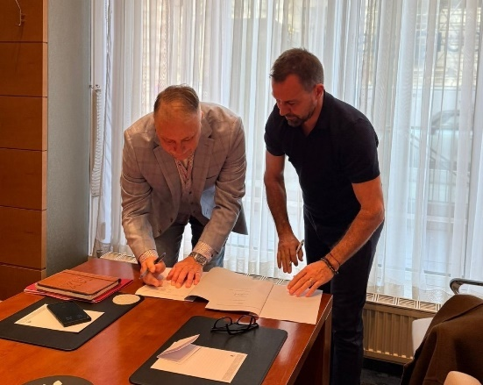

*Signing of a strategic agreement between the American businessman Michael Seifert (left) and the founder of the FUTTEC company Jiří Rušikvas on the establishment of the FUTTEC company operating in the North American market.*

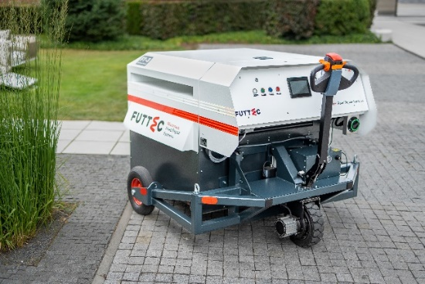

*The FT3 series "microwave patcher".*

**More about FUTTEC and its patented microwave technology*:***

*The company FUTTEC a.s. was founded in 2011 with the aim of developing a unique system for repairing potholes on roads. The technology, which is the result of many years of research and improvement, was created in cooperation with the Institute of Chemical Processes of the Academy of Sciences of the Czech Republic and VUT Brno. FUTTEC won the Visionaries 2019 award for it in the competition of the same name by the CzechInno association. In addition, it managed to obtain a subsidy of 1.8 million euros from the European Commission under the EU Horizon 2020 program for the commercialization of this innovative technology. FUTTEC is now seeking another EU grant under the EIC Accelerator program.*

*The patented FUTTEC® technology is intended for the permanent repair of potholes on asphalt surfaces on roads, cycle paths and other asphalt surfaces. It works on the principle of heating asphalt mixtures using microwave technology, which ensures deep heating of the repaired area without degradation of the asphalt mixture. The result is high strength and a long service life of the repaired site. Thanks to this principle, road repair can be carried out all year round, i.e. even in winter. Other advantages of FUTTEC microwave technology include speed, flexibility, efficiency and cost savings as well as human resources, environmental friendliness, health safety and transparency (a protocol is created during the repair, which is a warranty certificate for the repair).*

***More information:***

**Crest Communications**

Marie Cimplová, phone 731 613 602, [marie.cimplova@crestcom.cz](mailto:marie.cimplova@crestcom.cz)

Kamila Čadková, phone: 731 613 609, [kamila.cadkova@crestcom.cz](mailto:kamila.cadkova@crestcom.cz)

[**www.crestcom.cz**](http://www.crestcom.cz)

**FUTTEC**

Ondřej Rušikvas, phone 602 363 204, [ondrej.rusikvas@futtec.cz](mailto:ondrej.rusikvas@futtec.cz)

[**www.futtec.cz**](http://www.futtec.cz)